

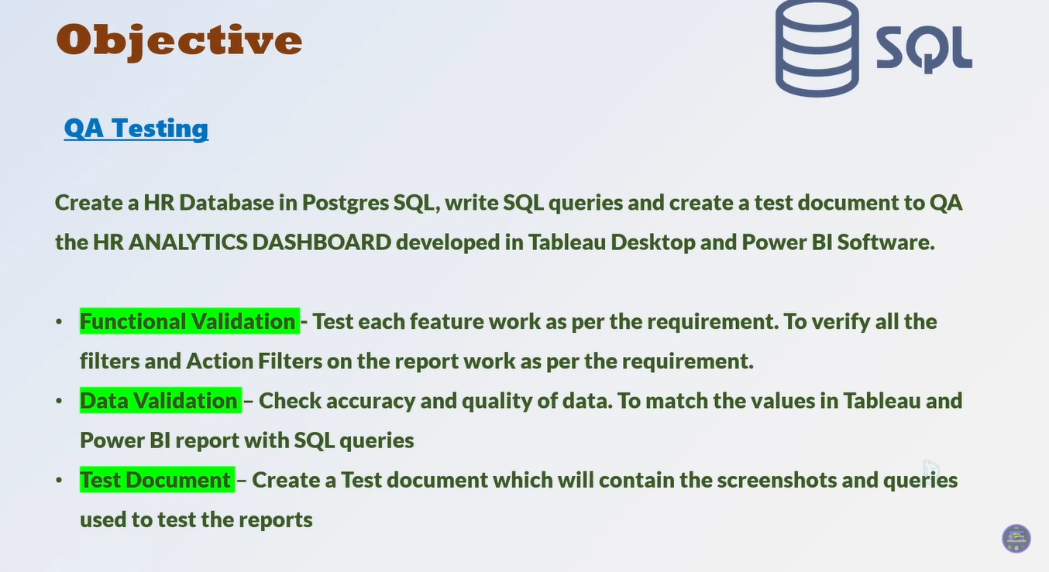

**TEST DOCUMENT**

|  |  |
| --- | --- |
| **Client Name** | Data Tutorials |
| **Report Name** | HR Analytics Dashboard |
| **Developer Name** | Sarthak Chaudhary |
| **Tester Name** | Sarthak Chaudhary (Self-Tested) |
| **Project Manager** | Self-Managed Project |
| **Development Tool** | **Power BI, Microsoft Excel** |

|  |  |  |  |  |
| --- | --- | --- | --- | --- |
| **Test No.** | **Sheet Name** | **Query** | **Test Result** | **QA Remark** |
| 1 | KPI- Employee Count | select sum(employee_count) as Employee_Count from hrdata; | Pass | Exact match |
| 2 | KPI- Attrition Count | select count(attrition) from hrdata where attrition='Yes'; | Pass | Exact match |
| 3 | KPI- Attrition Rate | select  round (((select count(attrition) from hrdata where attrition='Yes')/  sum(employee_count)) * 100,2)  from hrdata; | Pass | Exact match |
| 4 | KPI- Active Employee | select sum(hr.employee_count) - (select count(attrition) from hrdata where attrition='Yes') from hrdata; | Pass | Exact match |
| 5 | KPI- Average Age | select round(avg(age),0) from hrdata; | Pass | Exact match |
| 6 | Attrition by Gender | select gender, count(attrition) as attrition_count from hrdata  where attrition='Yes'  group by gender  order by count(attrition) desc; | Pass | Exact match |
| 7 | Department wise Attrition | select department, count(attrition), round((cast (count(attrition) as numeric) /  (select count(attrition) from hrdata where attrition= 'Yes')) * 100, 2) as pct from hrdata  where attrition='Yes'  group by department  order by count(attrition) desc; | Pass | Exact match |
| 8 | No of Employee by Age Group | select age_band, gender, sum(employee_count) from hrdata  group by age_band, gender  order by age_band, gender desc | Pass | Exact match |
| 9 | Education Field wise Attrition | select education_field, count(attrition) as attrition_count from hrdata  where attrition='Yes'  group by education_field  order by count(attrition) desc; | Pass | Exact match |
| 10 | Attrition Rate by Gender for different Age group | select age_band, gender, count(attrition) as attrition,  round((cast(count(attrition) as numeric) / (select count(attrition) from hrdata where attrition = 'Yes')) * 100,2) as pct  from hrdata  where attrition = 'Yes'  group by age_band, gender  order by age_band desc; | Pass | Exact match |
| 11 | Job Satisfaction Rating | SELECT * FROM  crosstab('SELECT job_role, job_satisfaction, sum(employee_count)  FROM hrdata  GROUP BY job_role, job_satisfaction  ORDER BY job_role, job_satisfaction'  ) AS ct(job_role varchar(50), one numeric, two numeric, three numeric, four numeric)  ORDER BY job_role; | Pass | Exact match |

**Test Result:**

|  |  |
| --- | --- |
| **Total Tests** | 11 |
| **Pass** | 11 |
| **Fail** | 00 |
| **Blocked** | 00 |
| **Not Executed** | 00 |